**#Problem 1:** **2nd-order mass-spring-damper system**

Here we use integrator to get the value of x.

We use the below formila to solve this out:



Or, 

With parameters *m* = 0.3, *c* = 0.3, *k* = 2.5. The input *f* (*t*) is a step function with magnitude 3.

The model :

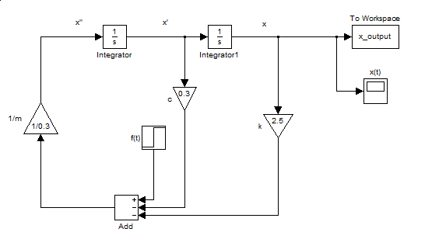

Here ,t= 15.0

The scope output:

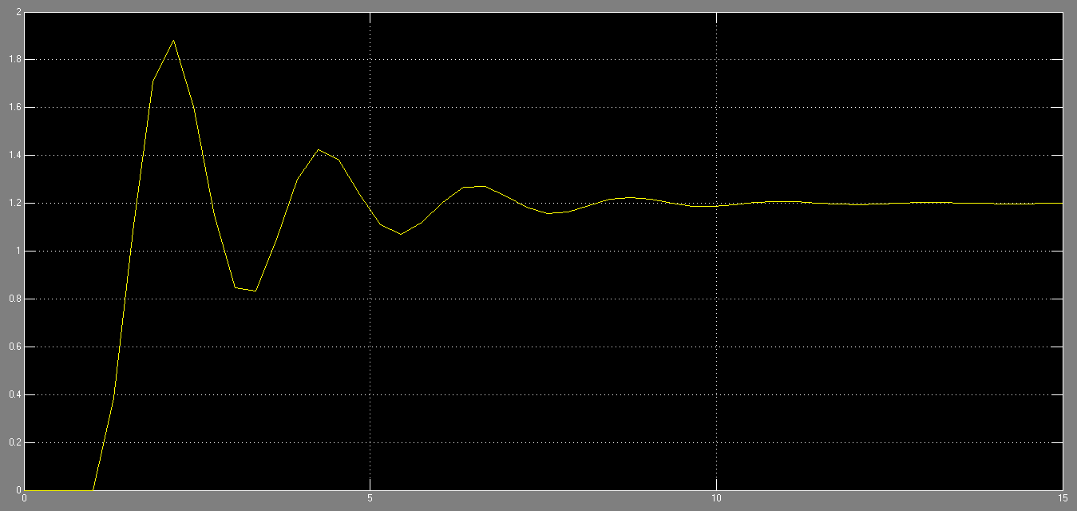

The code for plotting:

sim('PP2_Q1');

plot(x_output.time, x_output.signals.values, 'r-.x');

xlabel('t');

ylabel('X(t)');

legend('X(t)');

The ploted graph: 

**#Problem 2:** **Two-factor worm propagation model**

The model :

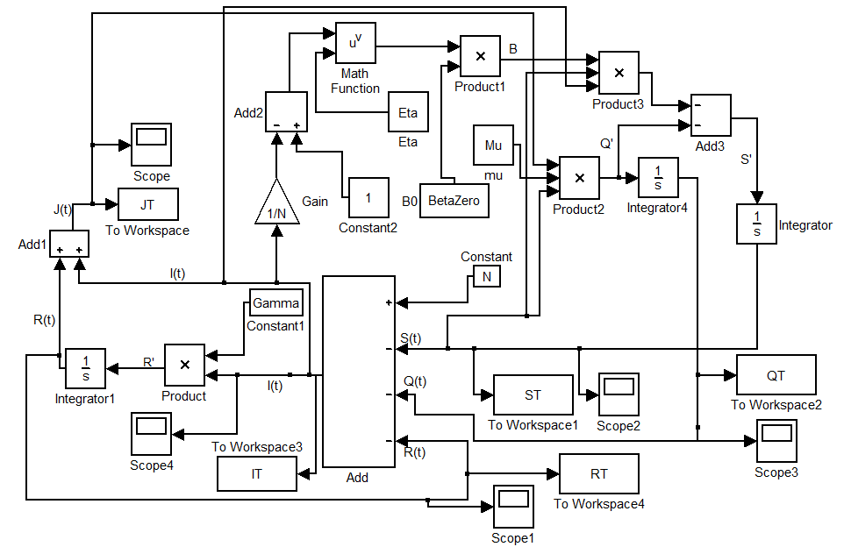

Here, t = 350

The scope output:

For J(t)

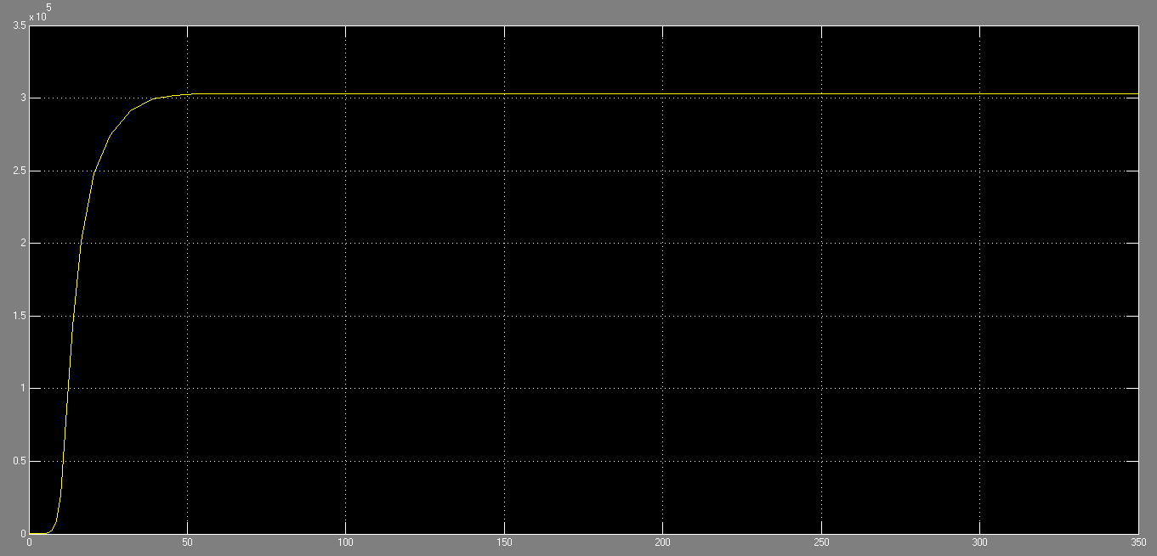

For I(t)

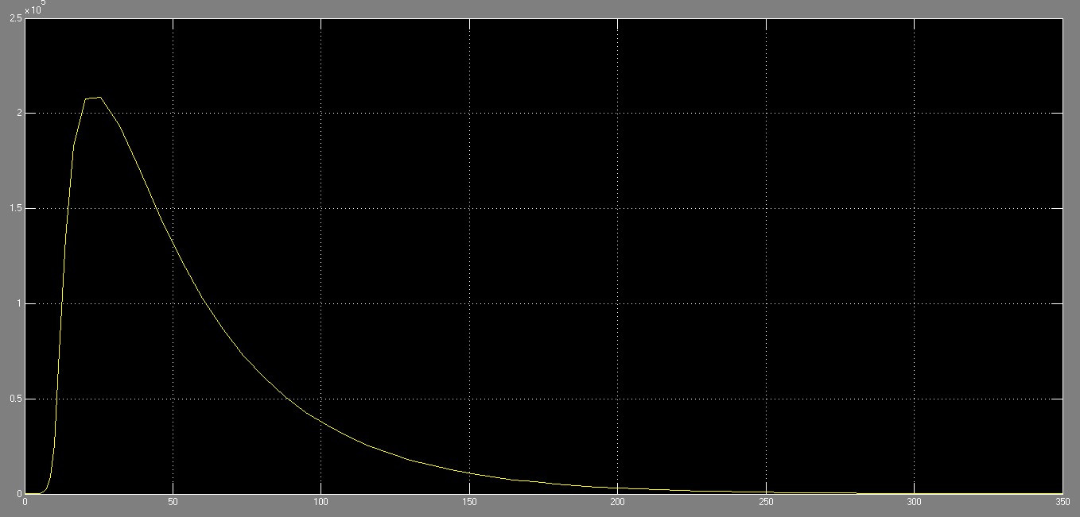

For Q(t)

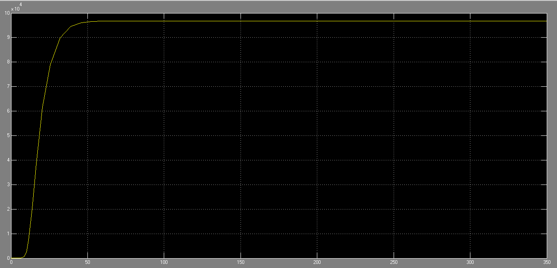

The code for plotting:

N=400000;

IZero=2;

Eta=2.5;

Gamma=0.025;

Mu=0.08/N;

BetaZero=1/N;

sim('PP2_Q2.mdl');

hold on;

plot(JT.time, JT.signals.values,'y:s');

plot(IT.time, IT.signals.values,'m--o');

plot(QT.time, QT.signals.values,'c-.^');

legend('J(t)','I(t)','Q(t)');

xlabel('Time'); ylabel('No of Hosts');

title('The Two-Factor Worm Propagation');

The ploted graph:

